BANK LOAN QUERY DOCUMENT
- BANK LOAN REPORT | SUMMARY

KPI’s :

Total Loan Applications:

select count(id) Total_Loan_Applications from bank_loan_data
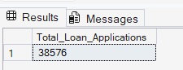

MTD Loan Applications:

select count(id) MTD_Total_Loan_Applications
from bank_loan_data
where month(issue_date) = 12 and year(issue_date) = 2021
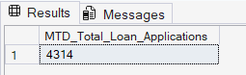

PMTD Loan Applications:

select count(id) PMTD_Total_Loan_Applications
from bank_loan_data
where month(issue_date) = 11 and year(issue_date) = 2021
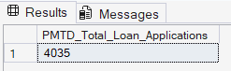
----------------------------------------------------------------------------------------------------------------------

Total Funded Amount:

select sum(loan_amount) Total_Funded_Amount
from bank_loan_data
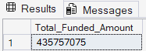

MTD Total Funded Amount:

select sum(loan_amount) MTD_Total_Funded_Amount from bank_loan_data
where month(issue_date) = 12 and year(issue_date) = 2021
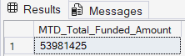

PMTD Total Funded Amount:

select sum(loan_amount) PMTD_Total_Funded_Amount from bank_loan_data
where month(issue_date) = 11 and year(issue_date) = 2021
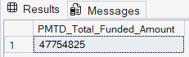
-------------------------------------------------------------------------------------------------------------------------

Total Amount Received:

select sum(total_payment) Total_Amount_received from bank_loan_data
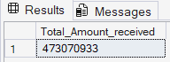

MTD Total Amount Received:

select sum(total_payment) MTD_Total_Amount_received from bank_loan_data
where month(issue_date) = 12 and year(issue_date) = 2021
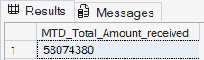

PMTD Total Amount Received:
select sum(total_payment) PMTD_Total_Amount_received from bank_loan_data
where month(issue_date) = 11 and year(issue_date) = 2021
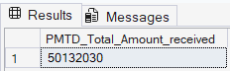
--------------------------------------------------------------------------------------------------------------------------
Average Interest Rate:

select avg(int_rate)*100 Avg_Interest_Rate from bank_loan_data
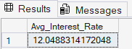

MTD Average Interest Rate:

select avg(int_rate)*100 MTD_Avg_Interest_Rate from bank_loan_data
where month(issue_date) = 12 and year(issue_date) = 2021
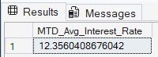

PMTD Average Interest Rate:

select avg(int_rate)*100 PMTD_Avg_Interest_Rate from bank_loan_data
where month(issue_date) = 11 and year(issue_date) = 2021
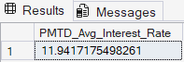
--------------------------------------------------------------------------------------------------------------------------
Avg DTI:

select avg(dti)*100 Avg_DTI from bank_loan_data
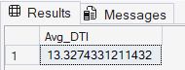

MTD Avg DTI:

select avg(dti)*100 MTD_Avg_DTI from bank_loan_data
where month(issue_date) = 12 and year(issue_date) = 2021
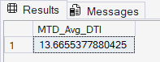

PMTD Avg DTI:

select avg(dti)*100 PMTD_Avg_DTI from bank_loan_data
where month(issue_date) = 11 and year(issue_date) = 2021
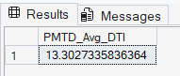
--------------------------------------------------------------------------------------------------------------------------

GOOD LOAN ISSUED
Good Loan Percentage:

select (count(case when loan_status = 'Fully Paid' or loan_status = 'Current' then id end)*100.0) / count(id) Good_Loan_Percentage
from bank_loan_data
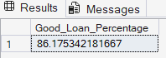

Good Loan Applications:

select count(id) Good_Loan_Applications
from bank_loan_data
where loan_status = 'Fully Paid' or loan_status = 'Current'
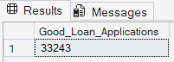

Good Loan Funded Amount:

select sum(loan_amount) Good_Loan_Funded_Amount
from bank_loan_data
where loan_status = 'Fully Paid' or loan_status = 'Current'
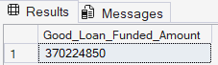

Good Loan Total Received Amount:

select sum(total_payment) Good_Loan_Recieved
from bank_loan_data
where loan_status = 'Fully Paid' or loan_status = 'Current'
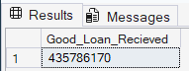
-------------------------------------------------------------------------------------------------------------------------

BAD LOAN ISSUED
Bad Loan Percentage:
select (count(case when loan_status = 'Charged Off' then id end)*100.0) / count(id) Bad_Loan_Percentage
from bank_loan_data
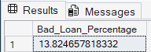

Bad Loan Applications:

select count(id) Bad_Loan_Applications
from bank_loan_data
where loan_status = 'Charged Off'
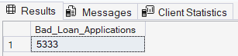

Bad Loan Funded Amount:

select sum(loan_amount) Bad_Loan_Funded_Amount
from bank_loan_data
where loan_status = 'Charged Off'
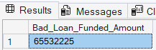

Bad Loan Total Received Amount:

select sum(total_payment) Bad_Loan_Recieved
from bank_loan_data
where loan_status = 'Charged Off'
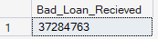

--------------------------------------------------------------------------------------------------------------------------

LOAN STATUS
select loan_status ,
count(id) Total_Loan_Application ,
sum(total_payment) Total_Amount_Received ,
sum(loan_amount) Total_Funded_Amount ,
avg(int_rate * 100) Interest_Rate ,
avg(dti * 100) DTI
from bank_loan_data
group by loan_status
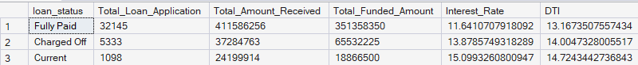

select loan_status ,
sum(total_payment) MTD_Total_Amount_Received ,
sum(loan_amount) MTD_Total_Funded_Amount
from bank_loan_data
where month(issue_date) = 12
group by loan_status
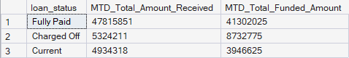

BANK LOAN REPORT | OVERVIEW
Month:

select month(issue_date) Month_Number,
datename(month, issue_date) Month_Name,
count(id) Total_Loan_Applications,
sum(loan_amount) Total_Funded_Amount,
sum(total_payment) Total_Received_Amount
from bank_loan_data
group by month(issue_date) , datename(month, issue_date)
order by month(issue_date)
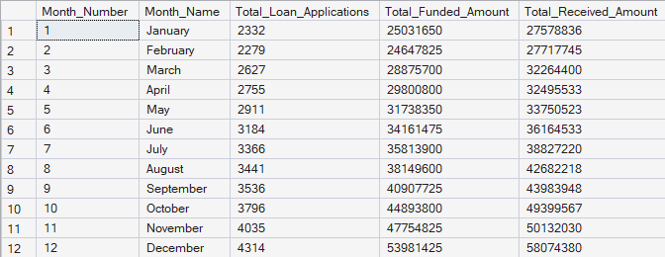

State:

select address_state,
count(id) Total_Loan_Applications,
sum(loan_amount) Total_Funded_Amount,
sum(total_payment) Total_Received_Amount
from bank_loan_data
group by address_state
order by address_state
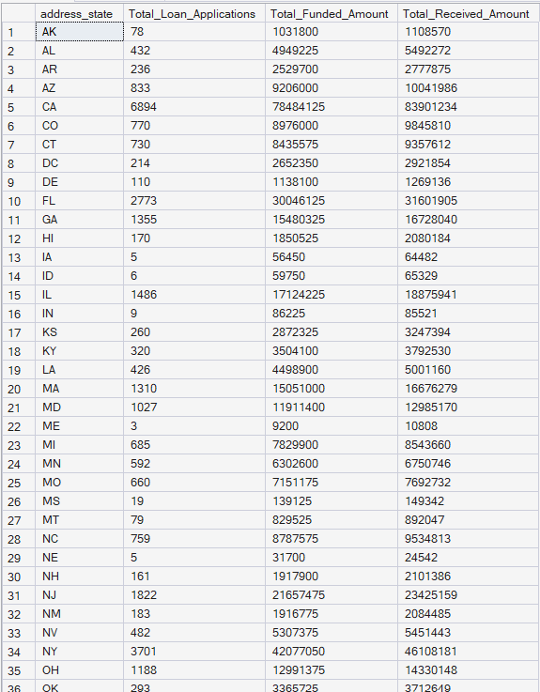

Term:

select term,
count(id) Total_Loan_Applications,
sum(loan_amount) Total_Funded_Amount,
sum(total_payment) Total_Received_Amount
from bank_loan_data
group by term
order by term
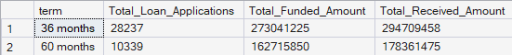

Purpose:

select
purpose AS PURPOSE,
count(id) AS Total_Loan_Applications,
sum(loan_amount) AS Total_Funded_Amount,
sum(total_payment) AS Total_Amount_Received
from bank_loan_data
group by purpose
order by purpose
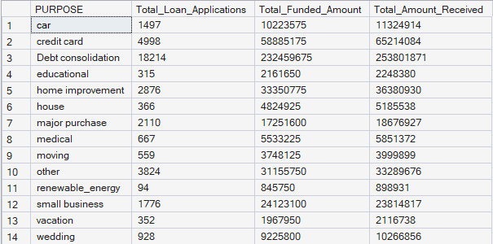

Home Ownership:

select
home_ownership,
count(id) AS Total_Loan_Applications,
sum(loan_amount) AS Total_Funded_Amount,
sum(total_payment) AS Total_Amount_Received
from bank_loan_data
group by home_ownership
order by home_ownership
